OPTICAL FIBER COMMUNICATION

AS MODERN TREND IN

INSTRUMENTATION & CONTROL
Prof.C.V.Kulkarni, Mr.Prashant D. Sarawade.
charudatta.kulkarni@mitcoe.edu.in
sarawade.prashant@gmail.com
Department of Electronics and Telecommunication
MIT-College Of Engineering, Kothrud, Pune
Affiliated to University of Pune,M.S(India)

Abstract: As Wireless communication is gaining a lot of significance day by day, there is adverse effect on physical and mental health of human lives. The high frequency radiations used in mobile communication will even cover wide range of communication; the acceptance of this type of communication has limitations across the world. The replacement for such is provided by optical fiber communication as modern trend in instrumentation and control. The basic system consists of source, communication wire and destination process. The instrumentation and control is applied to OFC to control and estimate losses and to improve the overall efficiency of communication system. The basic operation of optical fiber relies on total internal reflection of light. The optical fiber not only used in underground concern but also in marine and sea level applications. The wide acceptance of this communication across the world serves for multiple services trough a single cable .This multiway service fascination lead the reliance infocom to launch three way communication services such as internet service, cable telecast and telephone communication through single optical fiber. The project costs near about 35000 crores uses OFC with modern instrumentation and Control.
Keyword Optical Fiber communication , Instrumentation and Control.

I INTRODUCTION
Wireless Sensor Network (WSN) is composed of large number of sensor nodes which are low cost low power, thus it is need to investigate energy optimization methods. The sensor nodes are multifunction and in small size. Sensor nodes consist of sensing, data processing and communicating components. Sensor node collects parameter and transmits them to sink node. Energy constraints are an important issue in wireless sensor network. As battery powered sensor nodes are greatly constrained to prolong WSN lifetime. Since there is miniaturization of hardware components, it has become reality to develop intelligent sensor nodes with low cost and low power. Which are capable of data processing and wireless communication.
Wireless sensor networks becomes an important technology combining sensor technology, embedded computing, distributed information processing and wireless communication technology all together.WSN has broad application in medical monitoring, environmental pollution monitoring, target tracking ,military command and control. Data collection is basic requirement in all application of WSNs since data is critical for network to perform analysis and take action. To collect data well network coverage and connectivity are determinist factors. There are several important constraint in WSNs such as limitation of energy, memory and computation thus it is necessary to construct a network under such constraint.
The monitoring system in optimizing energy constraints basically consists of three modules as PC as master terminal, hardware interface using two slaves as ARM7 microprocessor under master ,wireless sensor network along with transreceiver modules. And sensor such as temperature, humidity, pressure, level etc. The system has modified features all sensors are in sleep mode and master’s request along with slave number and sensor number. The parameter can be taken for monitoring process. PC has VB software which directly displays the monitored data in tabular form along with graph of monitored parameter. We are using a master request and slave response. In this system a master send request to slaves one by one. In the request frame the master mentions slave ID. The request frame is received by all the slaves in the range. The slaves who are in the range receive the incoming frame and store it into internal RAM memory, and then they check for slave ID. If incoming slave ID matches with their own slave ID then they accept the frame and do the further instruction asked by the master. If ID does not match then slave discard the frame. The main idea is to conserve the energy of slaves and the sensor connected to it.
Many Research efforts have been devoted to sensor scheduling algorithm that turn off redundant sensor for energy saving since maintaining location information and time synchronization introduces extra energy and computational overhead This paper attempt for energy efficiency and high sensing coverage which can be achieved simultaneously by exploiting the spatial redundancy among sensing nodes.

II SYSTEM SPECIFICATIONS
A INPUT SPECIFICATIONS
1) Input parameter:
(a)Temperature sensor : LM35
LM35 is a series of precision integrated sensitive temperature sensor. Whose output is linearly related to degree centigrade. It has advantage over other linear sensors calibrated in Kelvin As user is not required to subtract the large constant output from his voltage to obtain convenient centigrade scale. it does not require any external triggering or calibration to provide typical accuracies. Low cost is achieved by trimming and calibration at the wafer level. LM 35 is low output impedance circuit; linear output and precise linear calibrated scale make the interfacing to readout or control circuit essentially easy. It can be used with single power supply or with plus or minus supply. The LM35 is rated to operate in the range -55to-150 C ranges.
1. Calibrated directly in degree Celsius.
2. Sensitivity: +10mv/°C.
3. Range: -55 to +150 degree Celsius.
4. Output range: 4 to 30 volts.
5. Operating current: 60μA
B) HUMIDITY SENSOR :HYSH220

C) PRESSURE SENSOR
The smart pressure device series of pressure sensor are silicon based and encapsulated in modulated plastic dual in line package to accommodate six pins for through board printed mounting .The sensor comes in two different types as Gauge and Absolute. The Gauge type merely measures the pressure with respect to atmospheric pressure the absolute type contains reference vacuum chamber which is formed on die during manufacturing. The output voltage of both sides is proportional to pressure that is measured. Various pressure ranges are available .because of bridge resistance value SPD pressure sensor are suited for the use in combination with transducer interface which gives an easy band accurate interface for digital electronics. 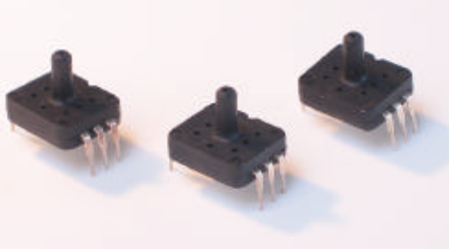

D)LIQUID LEVEL SENSOR
The SMD level switch and liquid level sensors are basically(a)Multilevel custom switches(b)Vertical Float switches (c)horizontal Float Switch (d)Optical Level Sensor etc.
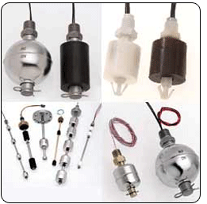
The system is characterized by,
1) 10-bit resolution in built adc.
2) 32 bit arm micro-controller.
3) Rs 232 for serial data transfer.
4) LCD display 16*2.
5) Xbee module 30 meters, 2.4 GHz operating frequency.
6) 5v, 200 ma current consumption.
7)display on pc using visual basic.
software overview
System softwares used are,
1)Programming of arm using ‘c’ in keil .
2)software programming at base station using visual basic (6.0)
Applications
1) Data logging in hazardous application such as nuclear plants, gas plants, chemical plants etc. . .
2) Wireless communication over long distances such as oil rigs

ARM CIRCUIT DIAGRAM
SLAVE:
The system block diagram consists of three modules as IBM PC, Two ARM microcontroller as Slave and XBEE as Communication Module along with Reset Section, Crystal Circuit,LCD section ,analog Connector and Xbee interface with ARM as indicated in hardware shown in ARM circuit as shown

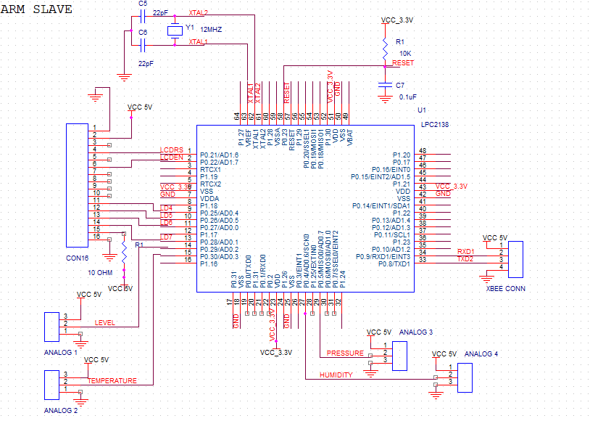

Here we making Xbee based network for weather monitoring application. we have master and slave structure for the weather monitoring .the range of Xbee is about 30 mtrs thus whole area cannot be covered by a single master or single slave .for this we are covering the whole area by a master and slave combination.
We have a main pc master terminal which has the vb software on it .the pc master terminal is used to monitor the status of all the slaves which covers the whole area to be monitored. here we are using a master request and slave response protocol .in this system the master sends the request to the slaves one by one. in the request frame the master mentions the slave id .the request frame is received by all the slaves which are in range .the slave who are in range receive the incoming frame and store it in its internal ram memory .then they check for the slave id .if the incoming slave id matches with their own slave id then they accept the frame and do the further instructions asked by master .if the id does not match then the slave discards the frame.
in our project we are using the above mentioned protocol.
in our system we have
1 Master PC terminal.
2 slave under master.
So in total we have 2 slaves .Here the main idea is to conserve energy of the slaves which are battery operated. As shown the 2 slaves are connected with 4 sensors each. These sensors consume a lot of energy considering they are battery operated.
So, we are going to cut the supply to the sensors of both the slaves. Which means that we are keeping the sensors in sleep mode.Whenever the request comes from the master side from xbee the slave µC turns on the supply to the particular sensor and the reading is then sent to the master. Again the particular slave is put to sleep.In this way we can conserve the energy .

RESET CIRCUIT
Reset is used for putting the microcontroller into a 'known' condition. That practically means that microcontroller can behave rather inaccurately under certain undesirable conditions. In order to continue its proper functioning it has to be reset, meaning all registers would be placed in a starting position. Reset is not only used when microcontroller doesn't behave the way we want it to, but can also be used when trying out a device as an interrupt in program execution, or to get a microcontroller ready when loading a program.
In order to prevent from bringing a logical zero RESET pin accidentally, RESET has to be connected via resistor to the positive supply pole AND a capacitor from RESET to the ground. Resistor should be between 5 and 10K and the capacitor can be in between 1µf tp 10 µf. This kind of resistor capacitor combination, gives the RC time delay for the µc to reset properly.
FIG 1 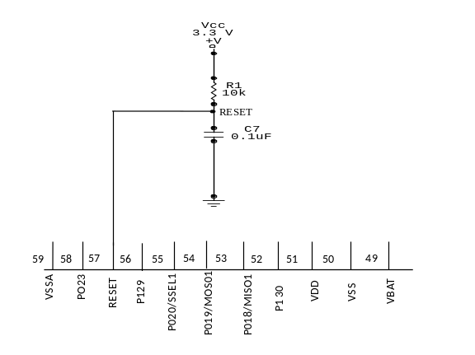

As shown in the above circuit we are connecting an RC circuit to the RESET (pin 57) of µC .The ARM µC has an active low reset, therefore we connect an RC circuit. As shown the capacitor is initially at 0v.It charges via the supply through a 10 kohm resistance in series, therefore the reset time of our circuit is:
R*C = 10kohm * 0.1 µf = 1 msec.
Recommended time of reset = 1 µsec
Here the RC time can vary from 10 µsec to 1 msec.

CRYSTAL CIRCUIT
Pins OSC1 & OSC2 are provided for connecting a resonant network to form oscillator. Typically a quartz crystal and capacitors are employed. The crystal frequency is the basic internal clock frequency of the microcontroller. The manufacturers make available PIC designs that can run at specified maximum & minimum frequencies, typically 1 MHz to 32 MHz.
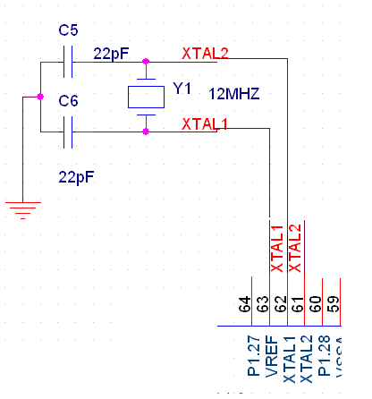
Here we are connecting twp ceramic capacitors which are basically used for filtering. In other words to give a pure square wave to the µC we are connecting the two capacitors. The basic rule for placing the crystal on the board is that it should be as close to the µC as possible to avoid any interference in the clock.
1.LCD has 2 power sources,
1st VCC and GND is at 1 and 2 NO. pins of LCD. Used to drive the LCD 3ma current consumption.
2nd VCC and GND is at 15 and 16 NO. pins of LCD.Used to drive the backlight of LCD. 100 ma current
Total current consumption = 3ma + 100ma = 103 ma
So, in order to reduce the current requirement we are connecting a5 ohm resistance in series with the backlight pin VCC. This reduces the current consumption (100ma / 10ohm = 10 ma).
Therefore new total current consumption =10ma+3 ma =13 ma.
2. LCD data and control lines
LCD has 8 / 4 data lines and 3 control lines .The 4 data lines of LCD (pin 11 to pin 14 of lcd) are connected to port 0 of the µC (0.26 , 0.27 , 0.28 , 0.29 ). The control lines are LCD RS, LCD R/W, LCD E. In this we are connecting only 2 lines, LCD E and LCD RS. The LCD RD/WR pin is grounded, since we only write into the LCD and never read from LCD. These 2 lines are connected to the port 0 (0.21 , 0.22 ) of the ARM µC. The LCD RS is for selecting the data or the code register .The LCD R/W is for choosing between reading or writing on LCD. LCDE is for enabling or disabling the LCD.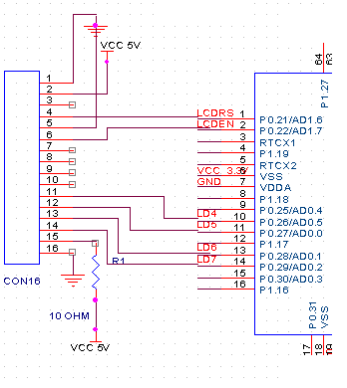
Here as we can see we are connecting the two analog parameters to the analog pins of ARM µC.(AD0.2, AD0.3).The µC has an inbuilt 10 bit ADC which digitizes the analog data and converts it into digital format .Once the data is available in the digital format the µC can process the data as required by the user program.

ARM INTERFACE TO XBEE MODULE:

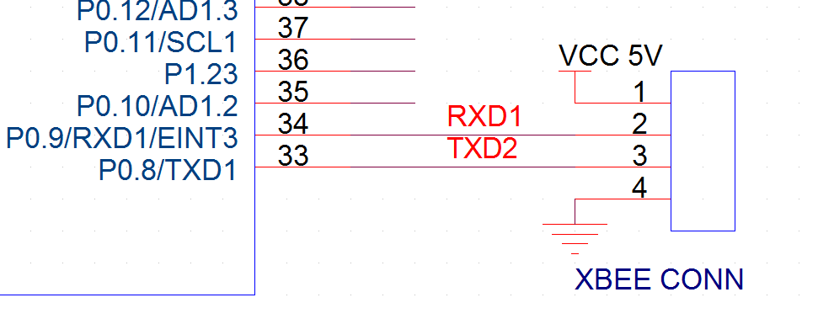
Here as we can see the XBEE module works on TTL Txd and Rxd pins so we can directly connect the µC txd pin to the XBEE rxd pin and the G rxd pin to the XBEE txd pin.

CONCLUSION
As conventional weather monitoring is continuous process but in disaster management weather changes occurs in sudden which disturb the human lives in such situation our system provide alertness by SMS. This paper aims for energy conservation of powered nodes which are battery operated by introducing sleep mode concept. The system can be implemented in naval research applications by introducing various latest algorithms such as randomized scheduling etc.

REFERENCES
1) W. Heinzelman,A Chandrashekarand H.Balakrishnan,”Energy efficient communication protocol for wireless sensor network” proceeding of 33rd Hawaii International conference
2) ARM
a) AN10535 LPC2138 extreme power down application note
Application note. Document information. Info. Content. Keywords. LPC2138, extreme power down. Abstract. This document describes a method to power down the ...
www.nxp.com/documents/application_note/AN10535
b) AN10421 Power management for LPC2138
Power management for LPC2138. 1. Introduction. The LPC2000 amilyofARM7. ...
c) Single-chip 16/32-bit microcontrollers; 32/64/128/256/512 kB ISP
Application note. Using IAP for LPC2000 ARM devices (v.2.0, 2004-10-25 ...
www.nxp.com/pip/LPC2131_32_34_36_38.html - Cached
3) LCDDatasheet Lcd 16x2
Datasheet LCD 16x2. Icon_archives_35x35 The LCD display Module is built in a LSI controller, the controller has two 8bitregisters,aninstruction ...
www.scribd.com/doc/18946526/Datasheet-Lcd-16x2
4) LCD-016M002B Datasheet pdf - 16 x 2 Character LCD - VishayCD-016M002B datasheet, LCD-016M002B pdf, LCD-016M002B data sheet, datasheet, data sheet, pdf, Vishay, 16 x 2 Character LCD.
www.datasheetcatalog.com/datasheets.../-/LCD-016M0

5) XBEEXBee® & XBee-PRO® 802.15.4 OEM RF Modules - Digi InternationalXBee 802.15.4 (formerly Series 1) OEM 2.4 GHz modules are ideal for low-cost, low-power wireless sensor networks.
6) XBee® & XBee-PRO® ZB ZigBee® PRO RF Modules - Digi International
XBee and XBee-PRO ZB embedded RF modules provide cost-effective...

